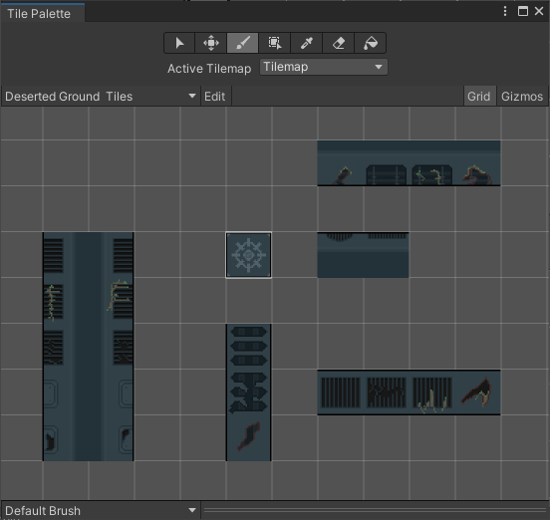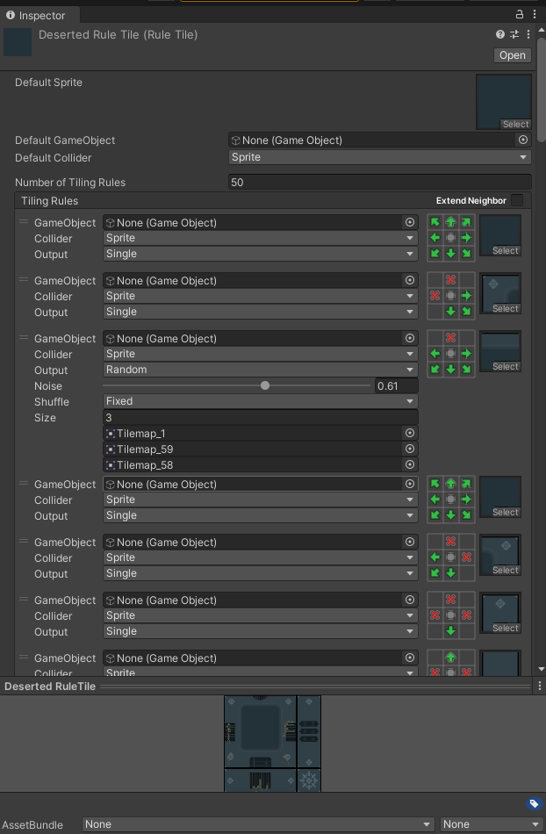
In this tilemap, the center cube is the Rule Tile containing everything. It can be used for building initially. However, the Rule Tile includes various versions of walls, roofs, and other elements, all randomized. This randomness might lead to a slightly chaotic map. Therefore, I have also listed the different versions of the walls, roofs, and other elements on the side. If you want to remove the randomness from the Rule Tile, you can go into the 'Deserted Rule Tile' and set all random tile sizes to 1. This will make the map cleaner, and you can manually add details using the tiles from the tile palette.

